**Project Development Phase**

**Sprint – 4**

|  |  |
| --- | --- |
| **Team ID** | **PNT2022TMID50805** |
| **Project Name** | **Hazardous Area Monitoring for Industrial Plant powered by IoT** |

Creating a mobile application:

**Screen 1 Frontend :**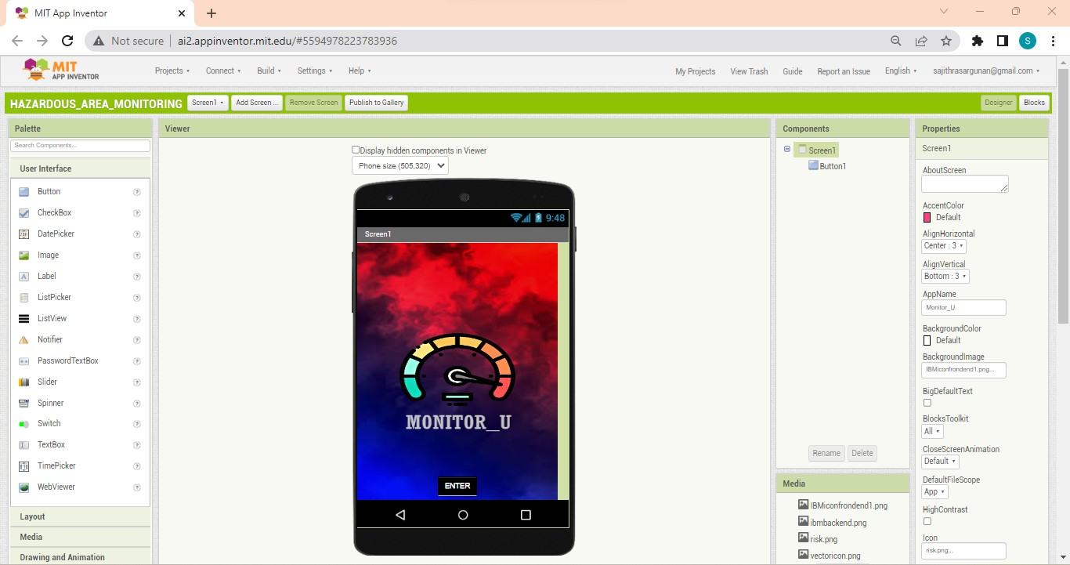

**Screen 1 Block:**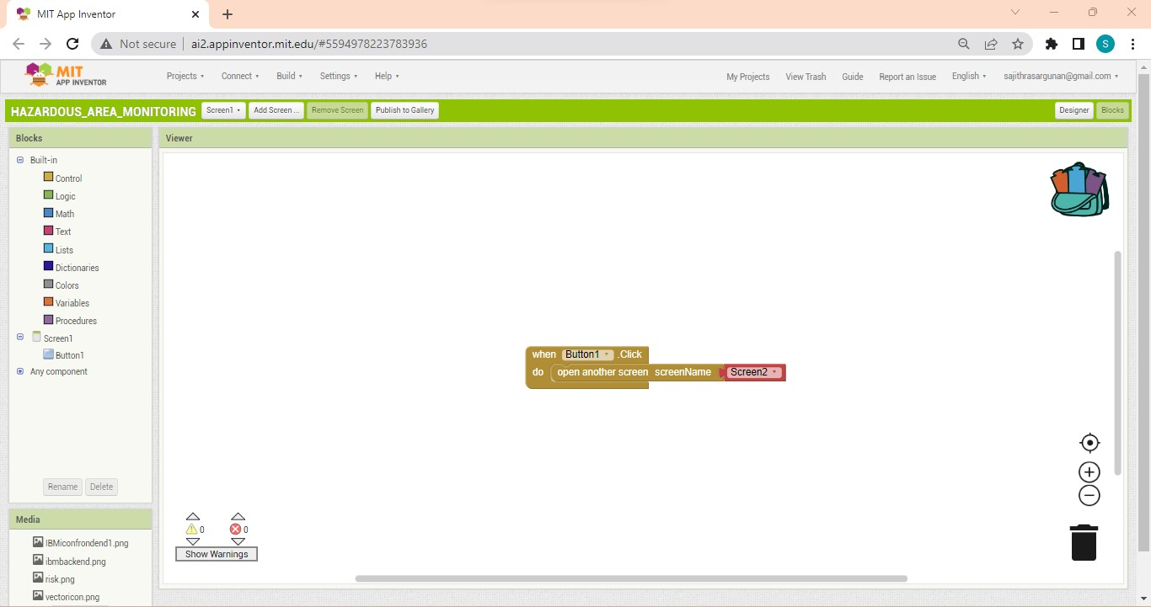

**Screen 2 User login:**

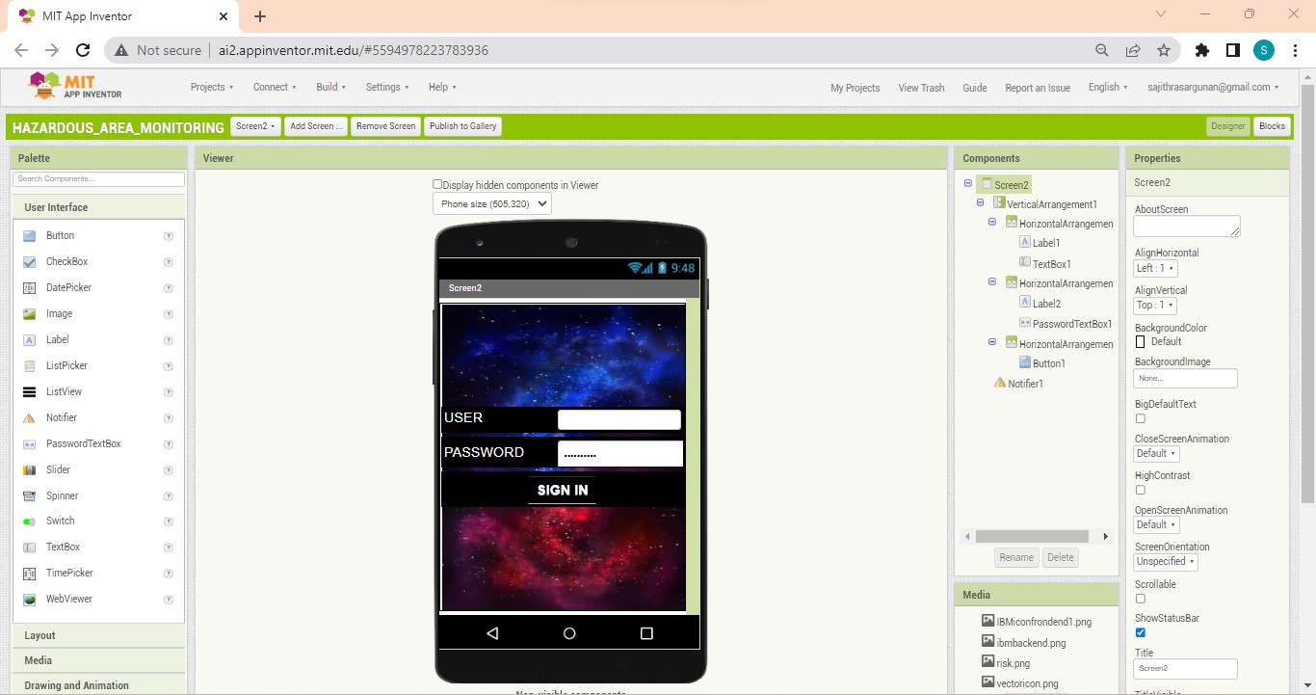

**Screen 2 Block:**

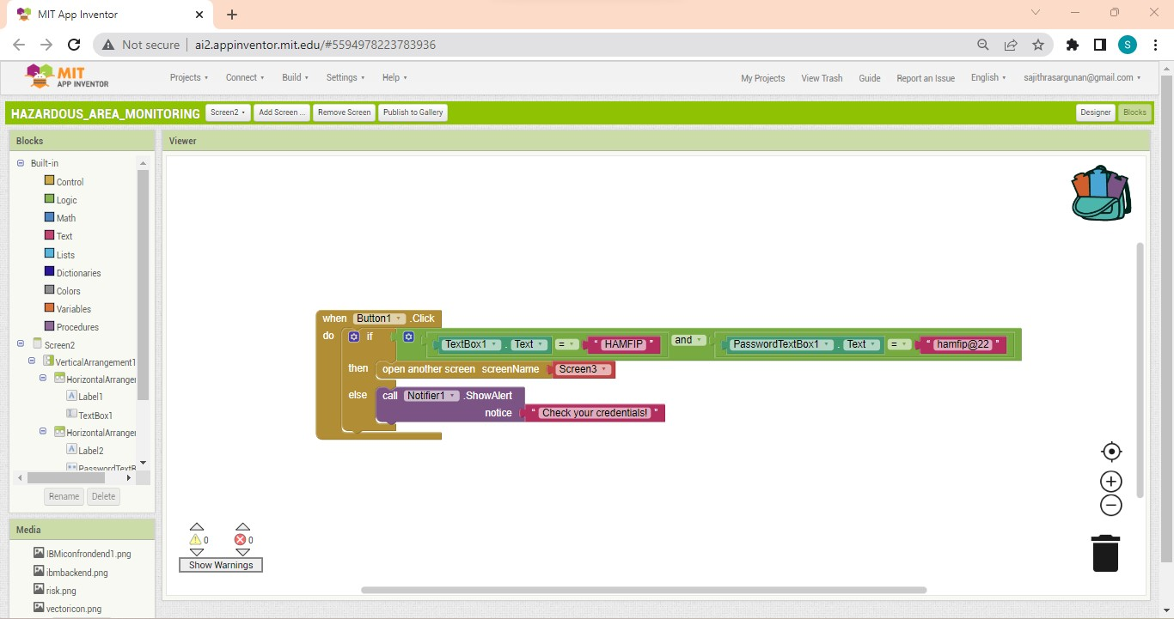

**Screen 3 Display Info:**

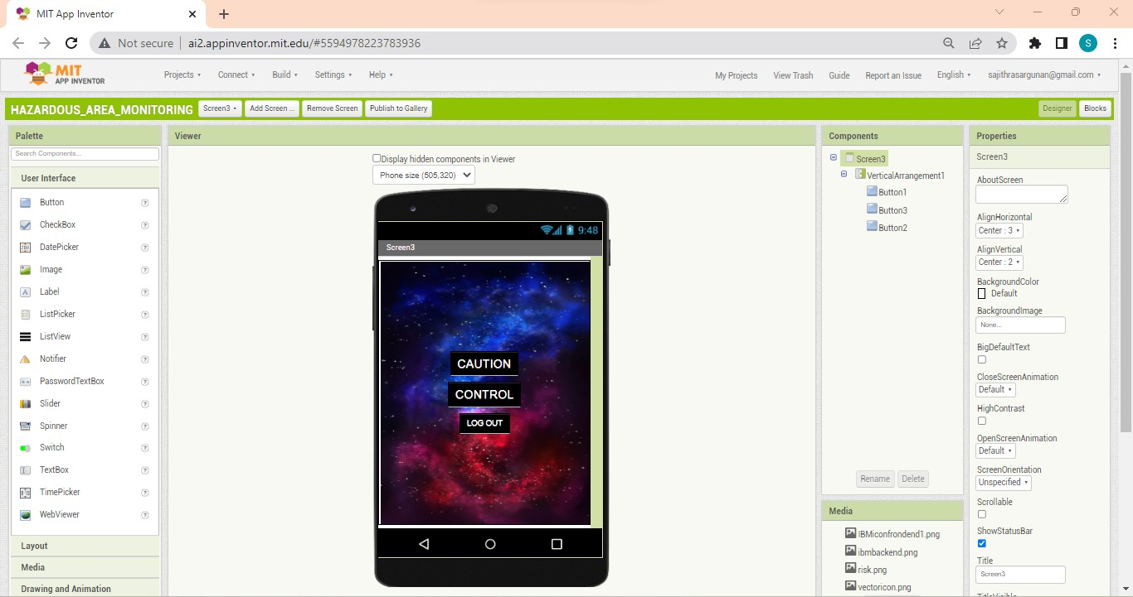

**Screen 3 Block:**

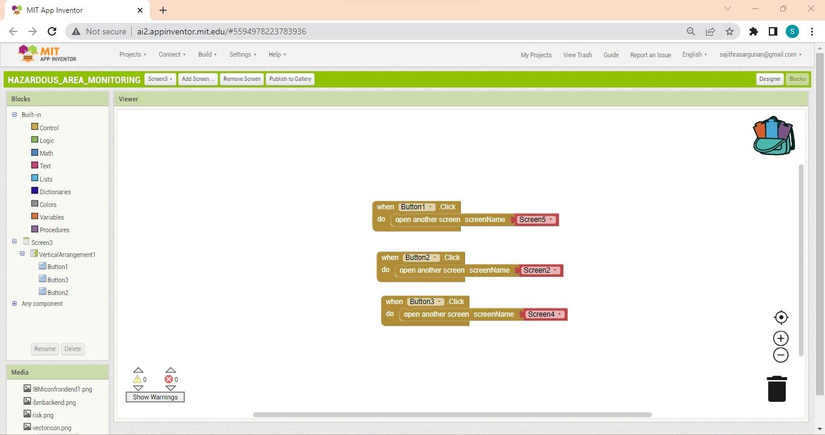

**Screen 4 Control Buttons:**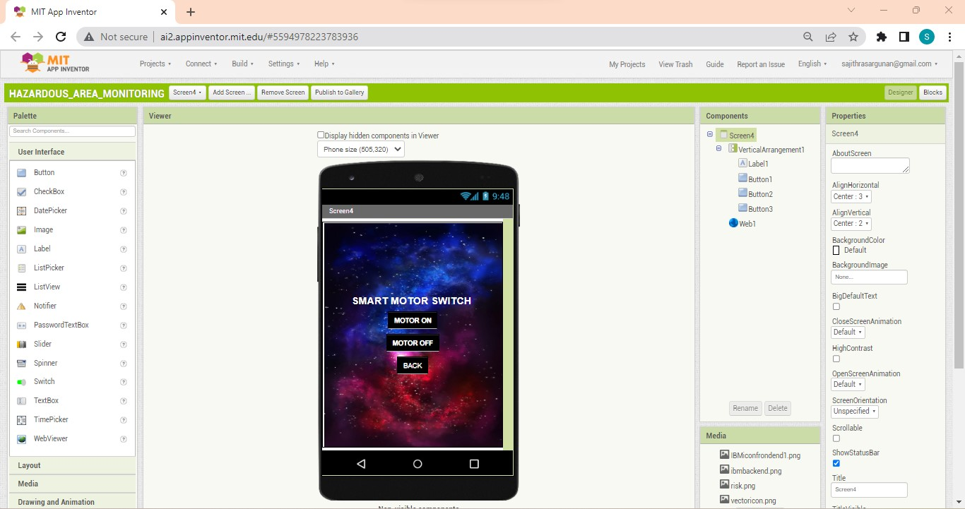

**Screen 4 Block:**

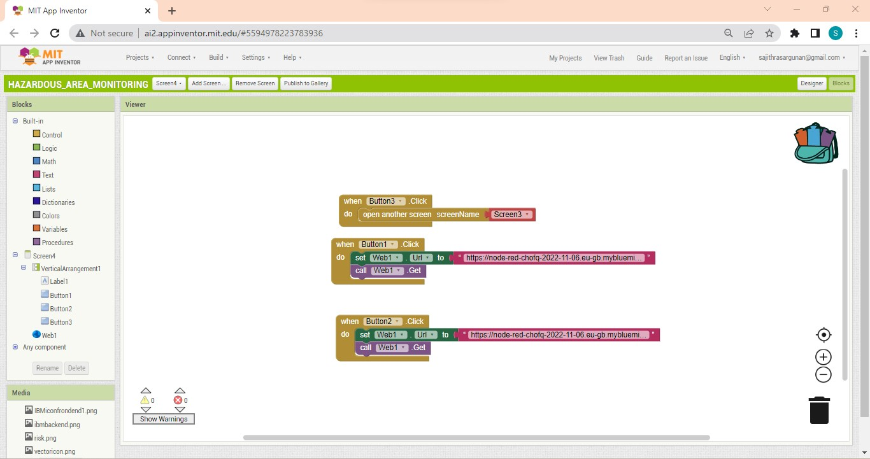

**Screen 5 Monitored Parameter Display:**

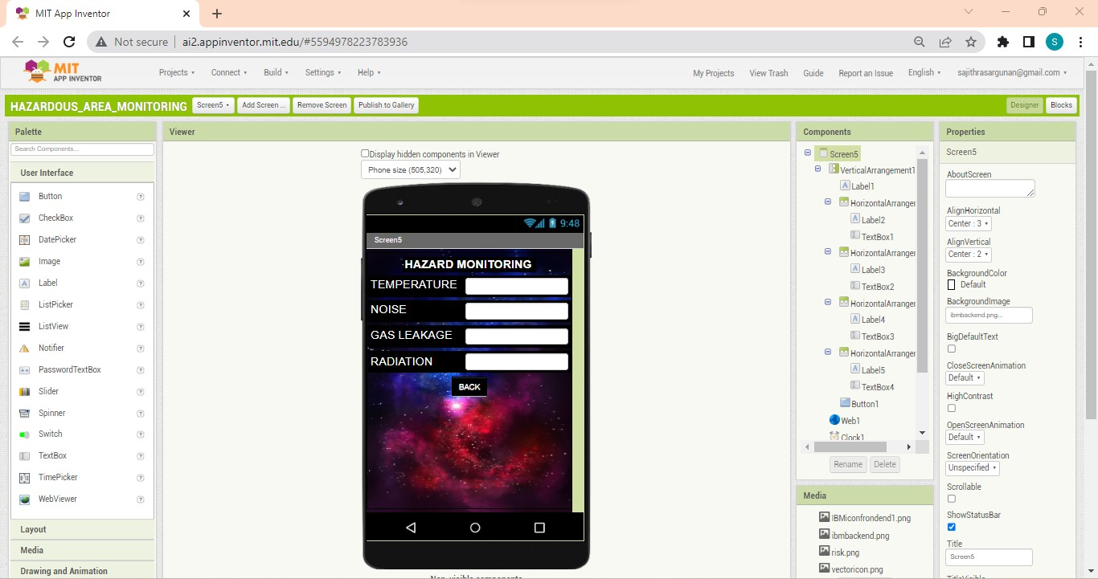

**Screen 5 Block:**

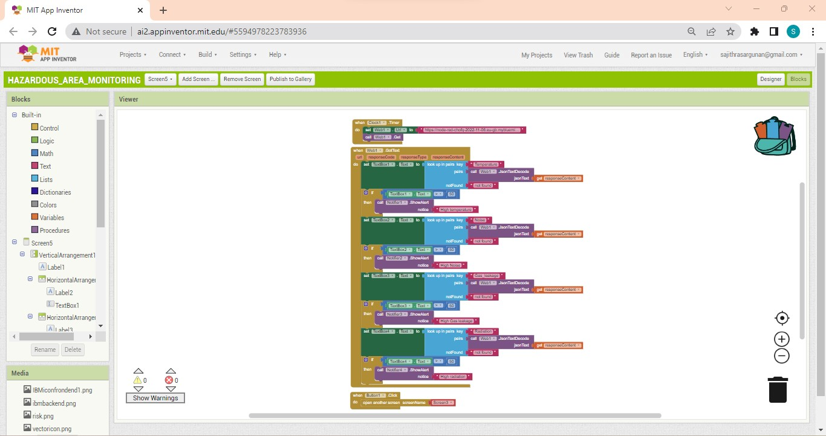

**Alert Notification To The User:**

